

**Mathematics Specialist**

**Test 6 2017**

**Statistical Inference**

**NAME: ____________SOLUTIONS____________________________ TEACHER: Mrs Da Cruz**

**Resource Rich**

**One unfolded A4 page of notes, SCSA formulae booklet and ClassPad calculator permitted**

**48 marks**

**45 minutes**

1. [1 mark]

A sample of 36 items has a mean of 28 and a standard deviation of 9. What is the standard deviation of the sampling mean?

Given:

$$n=36$$

$$\overline{x}=28$$

$$s=9$$

$$σ_{\overline{X}}=\frac{s}{\sqrt{n}}=\frac{9}{6}=1.5$$

**

1. [1 mark]

The sampling distribution of the mean mass of hands of Cavendish bananas was found to have a mean of 2.3 kg with a standard deviation of 0.1 kg for samples of 40 hands. What would be the standard deviation of individual hands?

Given:

$$n=40$$

$$μ_{\overline{X}}=2.3$$

$$σ_{\overline{X}}=0.1$$

$$σ_{\overline{X}}=\frac{σ}{\sqrt{n}}$$

$$0.1=\frac{σ}{\sqrt{40}}$$

$$σ≈0.632kg$$

**

1. [2 marks]

The average order at a takeaway shop is $22.59 with a standard deviation of $8.21. What is the probability that the next 10 orders will total more than $250?

$$σ_{\overline{X}}=\frac{8.21}{\sqrt{10}}$$

$$P\left(\overline{X}>\frac{250}{10}\right)=P(\overline{X}>25)≈0.1766$$

Given:

**

**

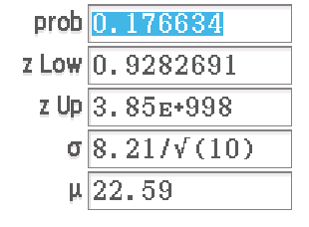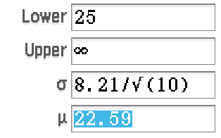

Note: The validity of this answer is not high since we do not know that the original data is normally distributed nor is the sample large enough. However, it is the only method we can use in this instance since we do know the sampling distribution of sample means is normal.

1. [2 marks]

A call centre servicing a national pizza chain has an average call length of 88 seconds, with a standard deviation of 20 seconds. The call lengths are normally distributed. What is the probability that an operator’s next 6 calls have an average length of between 90 and 100 seconds?

$$σ_{\overline{X}}=\frac{20}{\sqrt{6}}$$

$$P\left(90<\overline{X}<100\right)≈0.3324$$



Given:



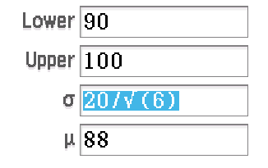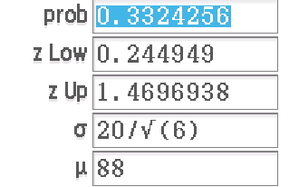

[2 marks]

What is the 99% confidence interval for the population mean if the mean of a sample of 50 is 34 with a standard deviation of 9?

Note: This row is unnecessary. Use your ClassPad. The question is only worth 2 marks.

$$C.I.: 34-2.576\left(\frac{9}{\sqrt{50}}\right)≤μ≤34+2.576\left(\frac{9}{\sqrt{50}}\right)$$

$$30.72≤μ≤37.28$$





Given:

$$\overline{x}=34$$

$$n=50$$

$$s=9$$

99% $⇒$ $z=2.576$

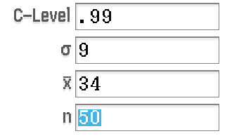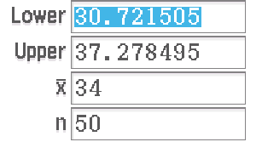

1. [4 marks]

What is the mean and standard deviation of a sampling distribution of a binomial distribution with   
p = 0.35 and n = 32 for samples of 45?

$$μ=np=32×0.35=11.2$$

$$σ=\sqrt{npq}=\sqrt{32×0.35×0.65}≈2.69815$$

$$∴μ_{\overline{X}}=11.2$$

$$σ_{\overline{X}}=\frac{2.69815}{\sqrt{45}}≈0.402$$





Given:

$$X\sim Bin(32, 0.35)$$

$$n=45$$





1. [3,3; 6 marks]

a A normal coin is tossed 10 times and the number of heads is noted. This experiment is repeated 1000 times. What is a graph of the results likely to look like? (Include characteristics like shape, mean, standard deviation.)



Key features to mention:

Symmetrical about 5 (since E(X) = np = 10 x 0.5 = 5)

Standard Deviation of about 1.6 (since $σ=\sqrt{npq}=\sqrt{10×0.5×0.5}≈1.6$

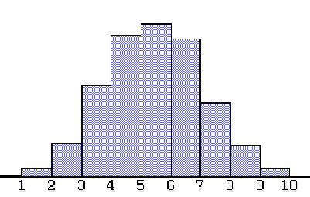

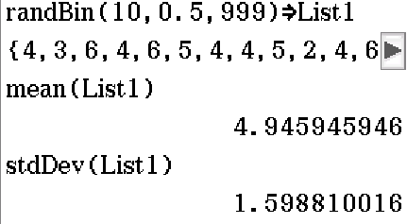

Note: 999 is used instead of 1000 as the ClassPad List can only accommodate max 999 entries. In addition, for a) and b) it was expected students would know what the distribution would look like without actually doing the simulations on ClassPad.

b Instead of graphing the results directly, the average numbers of heads in groups of 40 sets of 10 is calculated and these averages are graphed. What is this graph likely to look like? (Include characteristics like shape, mean, standard deviation.)

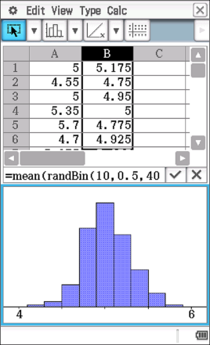****

Key features to mention:

Symmetrical about 5 ($μ_{\overline{X}}=5$)

Standard Deviation of 0.25 (since $σ_{\overline{X}}=\frac{\sqrt{10×0.5×0.5}}{\sqrt{40}}=0.25$)

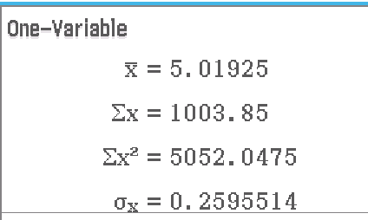

1. [4 marks]

What is the mean and standard deviation of a sampling distribution of sample means from a uniform distribution on the interval [15, 33] for samples of 40?

$$μ=\frac{15+33}{2}=24$$

$$σ=\sqrt{\frac{{\left(33-15\right)}^{2}}{12}}=3\sqrt{3}≈5.196$$

$$∴μ_{\overline{X}}=24$$

$$σ_{\overline{X}}=\frac{3\sqrt{3}}{\sqrt{40}}≈0.8216$$



Given:

$$X\sim U(15,33)$$

$$n=40$$







1. [5 marks]

From a survey of 600 people, it was reported that the 97% confidence interval for the weekly amount spent on transport was $75.60 to $84.90. What is the probability that, if you asked another 12 people, together they would spend more than a total of $1000 a week on transport?

Note: $σ_{\overline{X} }\left(n=600\right)≠σ_{\overline{X} }\left(n=12\right)$

$n=600$

97% C.I. $z=2.1701$

$$\overline{x}-2.1701\left(\frac{σ}{\sqrt{600}}\right)=75.6$$

$$\overline{x}+2.1701\left(\frac{σ}{\sqrt{600}}\right)=84.9$$

$$⇒\overline{x}≈80.25, σ≈52.48665$$

Or $σ_{\overline{X}}=2.143$

$$n=12$$

$$P\left(\overline{X}>\frac{1000}{12}\right)=P(\overline{X}>83\frac{1}{3})≈.4194$$



Given:

$$n=600$$

97% C.I.:







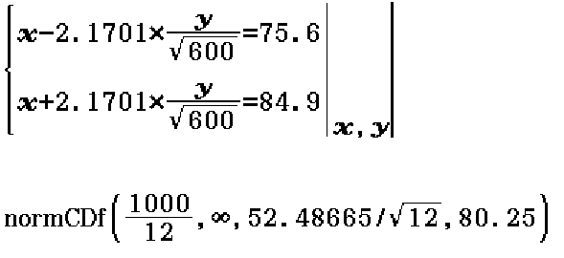

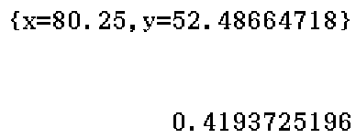

1. [3 marks]

A chocolate manufacturer claims that their *Chocolicious* chocolate bar have a mean weight of 45g with a standard deviation of 3g.

A competitor claims that this is false and that the mean weight is actually lower although they agree that the standard deviation is in fact 3g. They have lodged a complaint with Fairtrade Australia.

A sample of *Chocolicious* chocolate bars is to be checked to estimate the mean weight of the chocolate bars.

If we want to be 98% confident that the mean weight is within 1g of our sample mean, how many chocolate bars should we include in our sample?

$$n≥{\left(\frac{2.326×3}{1}\right)}^{2}$$

$$n≥48.69$$

$∴$ Need sample size of 49.



Given:

$$μ=45$$

$$σ=3$$

98% C.I.: $→z=2.326$

$$d=1$$





1. [10 marks; 2,2,2,2,2]

The weights of trout in a certain lake are normally distributed with a mean of 1.8 kg and a standard deviation of 0.28 kg. $Given: W\sim N(1.8, {0.28}^{2})$

1. If a trout is randomly selected from the lake, determine the probability that it weighs more than 1.6 kg given it weighs less than 1.9 kg.

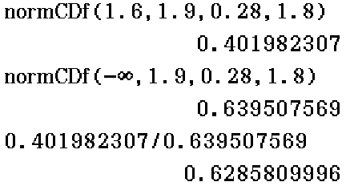****



1. If 20% of the trout in the lake are underweight, determine weight below which a trout is deemed to be underweight.

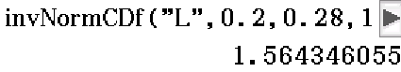****



A fishing and wildlife office makes a random selection of 25 trout.

1. 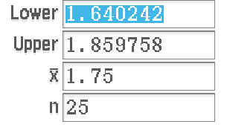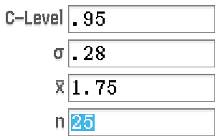****If the sample mean weight is 1.75 kg, determine a 95% confidence interval for the mean weight of the trout.

$$C.I.: 1.75-1.96\left(\frac{0.28}{\sqrt{25}}\right)≤μ≤1.75+1.96\left(\frac{0.28}{\sqrt{25}}\right) \\ 1.64≤μ≤1.86$$

Given: $\overline{x}=1.75$

$$n=25$$



1. Determine the probability that the sample mean lies between 1.62 kg and 1.93 kg.

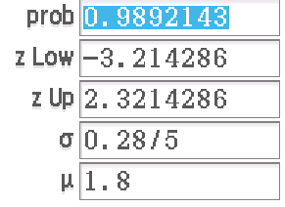****



1. What sample size is required to be 99% sure the sample mean is within 0.4 kg of the true population mean?

$$n≥{\left(\frac{2.576×0.28}{0.4}\right)}^{2}$$

$$n≥3.25$$

$∴$****

Need sample size of 4.



1. [8 marks; 3,4,1]

Samantha drives to work on each work-day. The mean time she takes to drive to work is $μ$ minutes with a standard deviation of 2 minutes.

1. The average time she takes to drive to work over a total of 40 work-days is 25 minutes with a standard deviation of 2 minutes. Determine a 99% confidence interval for $μ$ (correct to 1 decimal place.).



Working required since more than 3 marks.

$$C.I.: 25-2.576\left(\frac{2}{\sqrt{40}}\right)≤μ≤25-2.576\left(\frac{2}{\sqrt{40}}\right)$$

$$24.2 mins≤μ≤25.8 mins$$

Given: $\overline{x}=25$

$$n=40$$

$$s=2$$

99% $→z=2.576$



1. The average time she takes to drive to work over a total of $n$ work-days is $k$ minutes. A 99% confidence interval for $μ$ is $23.80≤μ≤25.20$. Find $k$ and $n$.

99% C.I. $z=2.576$

$$k-2.576\left(\frac{2}{\sqrt{n}}\right)=23.8$$

$$k+2.576\left(\frac{2}{\sqrt{n}}\right)=25.2$$

$$⇒k=24.5, n=54$$

$n$****



must be a whole number



1. Samantha calculates 10 sets of 90% confidence intervals to estimate $μ.$ How many of these confidence intervals are expected to contain $μ$?

$$9$$

